Domayne’s Wood and Uplift Ebony Bed

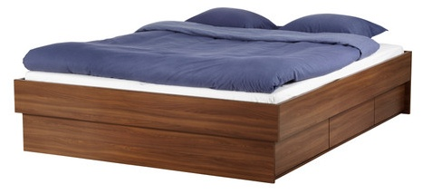

|  |
| --- |
| **DESCRIPTION** |
| Domayne introduces stylish bed with an mudded cactus bloom wood top and a rich cactus finish this set of bed is sure to create the perfect look in any home. The rich wood of the bed pairs perfectly with many different styles and rooms. Perfect for heart of the house, your guests will love this comfortable mood lifting bed. |

|  |  |  |
| --- | --- | --- |
| **Price** | **850$** | |
| **Dimensions** | **H** x **W** x **L** | **14in x 54in x 75in** |
| **Features** | **cactus wood with break proof metallic technology plus heat sensor adjustable fiber mass which makes it perfect for hard conditions** | |
| **Finished** | **Brown Polished Dime** | |
| **Available in** | **Brown, Black** | |